# Report

## Geo-coding

Geo-coding, the attribution of geographic coordinates to a postal address, is a geospatial problem people have been trying to solve since the advent of GIS in the 1960s. Reliable geo-coding has always been a concern in the property insurance market: After all, the first step in understanding the risk at a location is to know exactly where that location is. But in the last 15 years it has also become a concern for the consumer market, with perfection of consumer GPS location hardware and the ubiquitous Google Maps platform availability over phone networks.

## Problem statement

There is an Area 14 N Bond St, Mount Vernon, NY 10550, USA given to me for the purpose of Geo-coding.

I have planned to to have a rough estimate of more than one hundred shops including stores, hospitals, and restaurants. I have the address of these locations and their Zip codes

Here is the study area

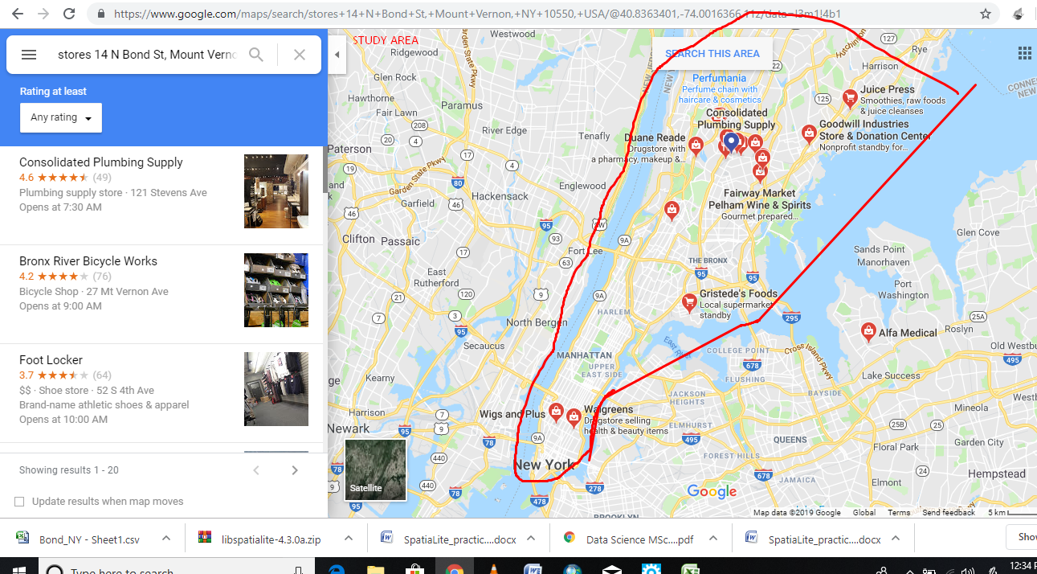

## Part 1 To create an Address Locator for your reference data layer: 1. Open ArcToolbox - Gecoding Tools and double-click on Create Address Locator

2. Click on Show Help in the bottom left corner of the dialog box for context sensitive help (you can click on the Help icon in that box for detailed instructions)

3. Click on the folder next to Address Locator Style to choose a style.

4. Under Reference Data, use the pull-down or Folder icon to select the GIS reference data you wish to use (e.g., street centerline, parcel points, zip code polygons)

5. Under “Role,” click and select “Primary table” or “Alias.” Primary is the most common choice. Alias is used for when a place has an address (14 N Bond St, Mount Vernon, NY 10550, USA)

6. The Field Map table should then populate after you make your selection - the field map links required information to fields in the reference file’s attribute table. Check to ensure everything is filled in correctly and fill in blanks as needed.

7. Under Output Address Locator, give the new file a name and store it on a drive to which you have write access (e.g., C on your personal computer)

Here is the step wise performance of Geo-coding.

